- BFS
Code:-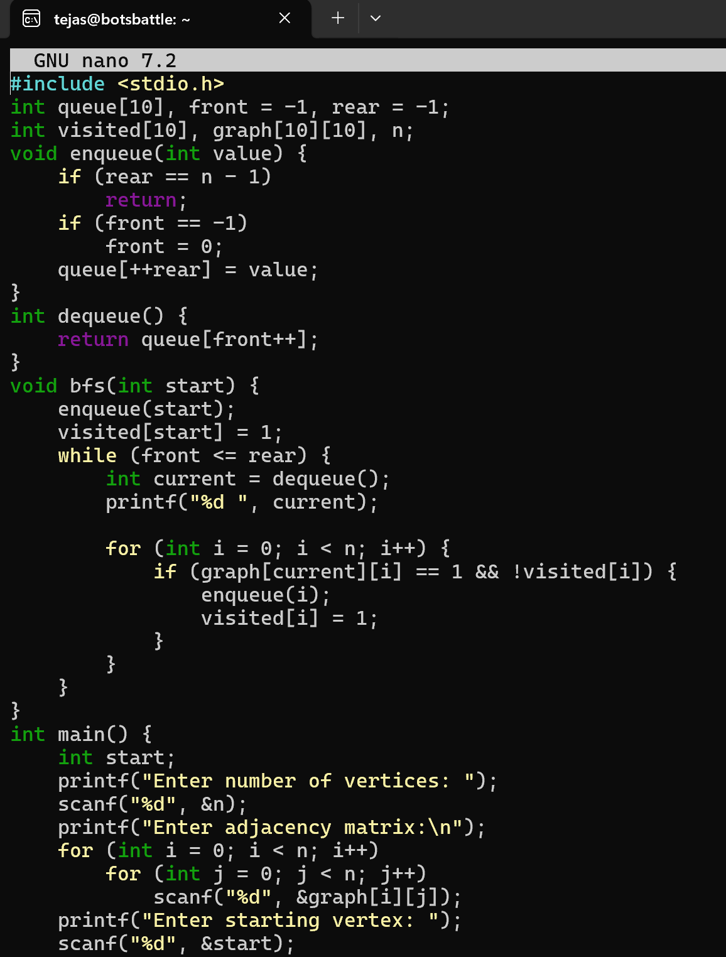
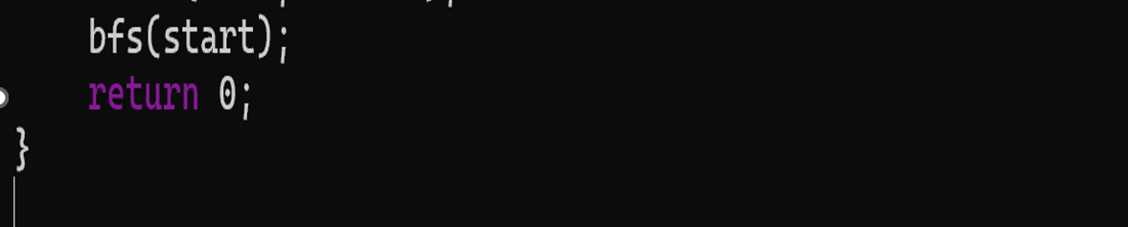
Output:-
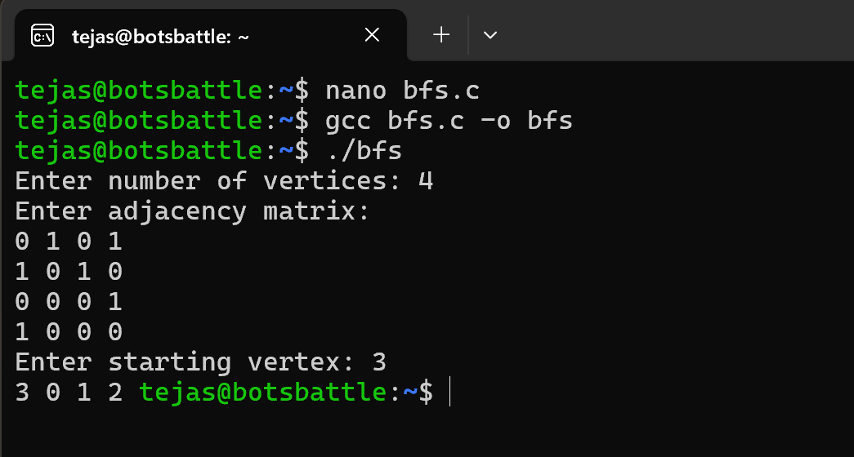
Interpretation:-
I wrote a C program to perform Breadth First Search on a graph. BFS works by visiting all neighbouring nodes first before moving to the next level. I used a queue to store the vertices that need to be visited and an array called visited to make sure no vertex is visited more than once. Starting from the given vertex, I inserted it into the queue and marked it as visited. Then, while the queue is not empty, I removed one vertex, printed it, and added all its unvisited adjacent vertices into the queue. This process continues until all reachable vertices are visited. BFS has a time complexity of O(V + E) because it visits every vertex and edge once, and its space complexity is O(V) due to the queue and visited array.

- DFS
Code:-
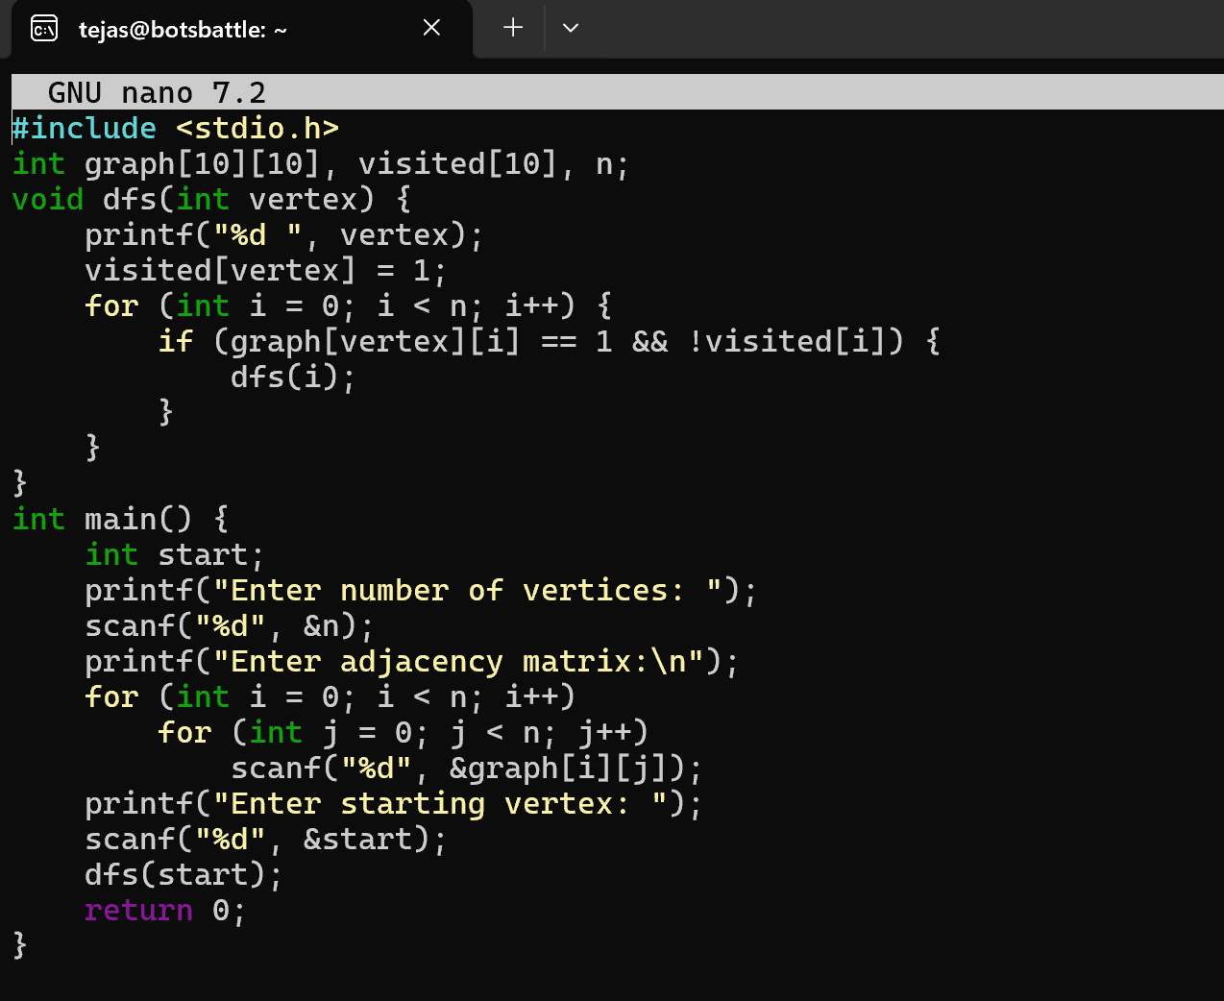
Output:-
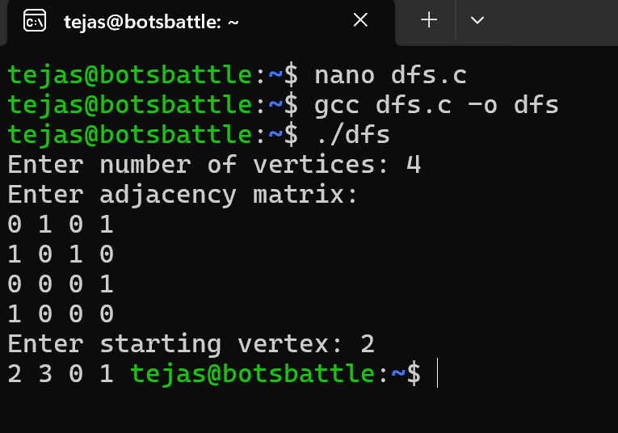
Interpretation:-
I wrote a C program to perform Depth First Search on a graph using recursion. DFS works by going as deep as possible along one path before backtracking. I used a recursive function called dfs() that takes a vertex as input, prints it, and marks it as visited. Then, for each adjacent vertex that has not been visited, the function calls itself recursively. This process continues until all vertices are visited. DFS has a time complexity of O(V + E) since every vertex and edge is visited once. Its space complexity is O(V) because of the recursive call stack and the visited array.

